INSTITUTE OF ECE
ECA14 – EMBEDDED SYSTEMS
NAME:G.DAFNIE
REGNO:192521265
LAB EXPERIMENTS:
1)FLASHING OF LED USING AT89C51 MICROCONTROLLER USING PROTEUS
AIM: To Write an assembly language program to flash the LED using AT89C51.
PROGRAM:
ORG 0000H
UP: SETB P2.0
ACALL DELAY
CLR P2.0
ACALL DELAY
SJMP UP
DELAY: MOV R4,#35
H1:MOV R3,#255
H2:DJNZ R3,H2
DJNZ R4,H1
RET
END
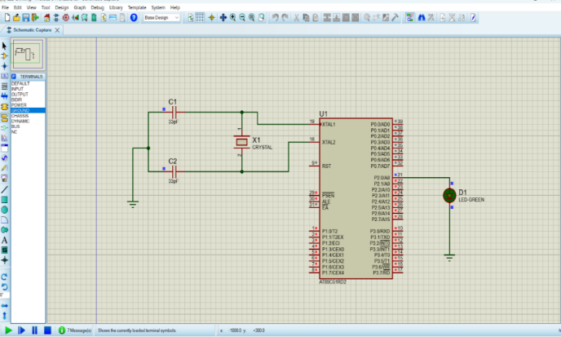
OUTPUT:
RESULT:
Thus the program has been successfully verified and executed.
2) GENERATION OF SQUARE WAVE USING PROTEUS
AIM:
To write an assembly language program to Generate square wave using AT89C51.
PROGRAM
ORG 0000H
UP: SETB P2.0
ACALL DELAY
CLR P2.0
ACALL DELAY
SJMP UP
DELAY: MOV R4,#35
H1:MOV R3,#255
H2:DJNZ R3,H2
DJNZ R4,H1
RET
END
OUTPUT:
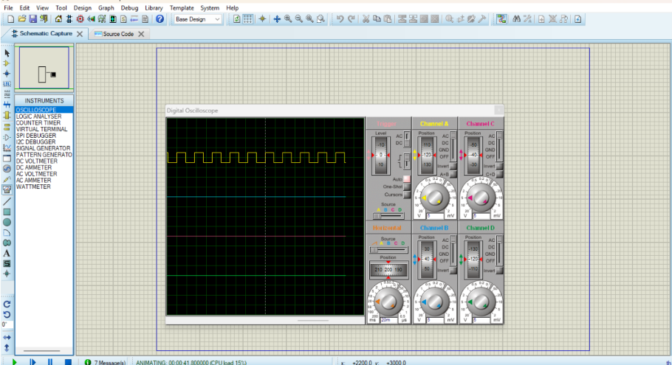
RESULT:
Thus the program has been successfully verified and executed.
2) STEPPER MOTOR USING AT89C51 USING PROTEUS
AIM:
To write an assembly language program for Stepper Motor Using AT89C51 using Keil and
Proteus
PROGRAM:
ORG 0000H
UP: MOV P2,#09H
ACALL DELAY
MOV P2,#0CH
ACALL DELAY
MOV P2,#06H
ACALL DELAY
MOV P2,#03H
ACALL DELAY
SJMP UP
DELAY:MOV R4,#18
H1:MOV R3,#255
H2:DJNZ R3,H2
DJNZ R4,H1
RET
END
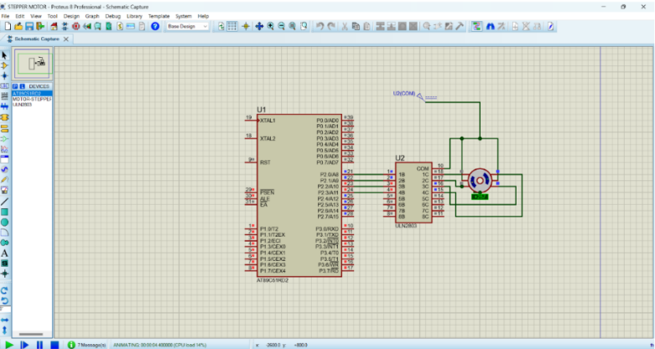
OUTPUT:
RESULT:
Thus the program has been successfully verified and executed.
3) 7 SEGMENT DISPLAY USING AT89C51 USING PROTEUS:
AIM:
To write an assembly language program for 7 Segment Display Using AT89C51 using Keil
and Proteus
PROGRAM:
ORG 000H
UP:MOV P2,#0C0H
ACALL DELAY
MOV P2,#0F9H
ACALL DELAY
MOV P2,#0A4H
ACALL DELAY
MOV P2,#0B0H
ACALL DELAY
MOV P2,#99H
ACALL DELAY
MOV P2,#92H
ACALL DELAY
MOV P2,#82H
ACALL DELAY
MOV P2,#0F8H
ACALL DELAY
MOV P2, #80H
ACALL DELAY
MOV P2,#90H
ACALL DELAY
DELAY: MOV R5,#10
H1:MOV R4,#180
H2:MOV R3,#255
H3:DJNZ R3,H3
DJNZ R4,H2
DJNZ R5,H1
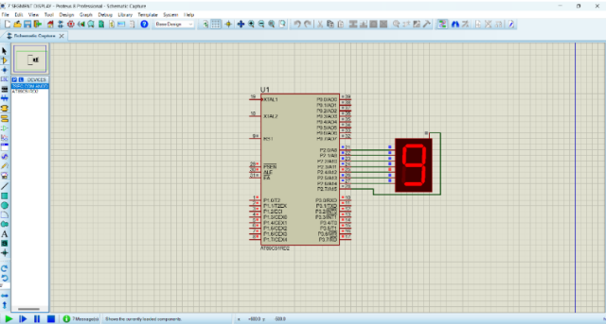
RET
9) ARDUINO BASED MANUAL ELECTRONIC COUNTER USING PROTEUS
AIM:
To write an Embedded C program for Manual Electronic counter using Arduino IDE and
Proteus.
PROGRAM:
int x0,x1,x2,x3,x4,x5,x6,x7,x8,x9;
int delay_time=200;

void setup() {
//configure pin2 as an input and enable the internal pull-up resistor
pinMode(12, INPUT_PULLUP);
pinMode(1,OUTPUT);

pinMode(2,OUTPUT);
pinMode(3,OUTPUT);
pinMode(4,OUTPUT);
pinMode(5,OUTPUT);
pinMode(6,OUTPUT);
pinMode(7,OUTPUT);

}
void loop() {
//read the pushbutton value into a variable
int sensorVal = digitalRead(12);

if (sensorVal == LOW) {
x0=true;
}
while(x0){
zero();
sensorVal = digitalRead(12);
if (sensorVal == LOW) {
x1=true;
x0=false;
}
}
while(x1){
one();
sensorVal = digitalRead(12);
if (sensorVal == LOW) {
x2=true;
x1=false;
}

}
while(x2){
two();
sensorVal = digitalRead(12);
if (sensorVal == LOW) {
x3=true;
x2=false;
}
}
while(x3){
three();
sensorVal = digitalRead(12);
if (sensorVal == LOW) {
x4=true;
x3=false;
}
}
while(x4){
four();
sensorVal = digitalRead(12);
if (sensorVal == LOW) {
x5=true;
x4=false;
}
}
while(x5){
five();
sensorVal = digitalRead(12);
if (sensorVal == LOW) {
x6=true;

x5=false;
}
}
while(x6){
six();
sensorVal = digitalRead(12);
if (sensorVal == LOW) {
x7=true;
x6=false;
}
}
while(x7){
seven();
sensorVal = digitalRead(12);
if (sensorVal == LOW) {
x8=true;
x7=false;
}
}
while(x8){
eight();
sensorVal = digitalRead(12);
if (sensorVal == LOW) {
x9=true;
x8=false;
}
}
while(x9){
nine();
sensorVal = digitalRead(12);

if (sensorVal == LOW) {
x0=true;
x9=false;
}
}

}

void zero()
{
for(int i=1;i<7;i++)
{
digitalWrite(i,HIGH);
digitalWrite(7,LOW);
}
delay(delay_time);
}

void one()
{
digitalWrite(1,LOW);
digitalWrite(2,HIGH);
digitalWrite(3,HIGH);
digitalWrite(4,LOW);
digitalWrite(5,LOW);
digitalWrite(6,LOW);
digitalWrite(7,LOW);
delay(delay_time);
}

void two()
{
digitalWrite(1,HIGH);
digitalWrite(2,HIGH);
digitalWrite(3,LOW);
digitalWrite(4,HIGH);
digitalWrite(5,HIGH);
digitalWrite(6,LOW);
digitalWrite(7,HIGH);
delay(delay_time);
}

void three()
{
digitalWrite(1,HIGH);
digitalWrite(2,HIGH);
digitalWrite(3,HIGH);
digitalWrite(4,HIGH);
digitalWrite(5,LOW);
digitalWrite(6,LOW);
digitalWrite(7,HIGH);
delay(delay_time);
}

void four()
{
digitalWrite(1,LOW);
digitalWrite(2,HIGH);
digitalWrite(3,HIGH);
digitalWrite(4,LOW);

digitalWrite(5,LOW);
digitalWrite(6,HIGH);
digitalWrite(7,HIGH);
delay(delay_time);
}

void five()
{
digitalWrite(1,HIGH);
digitalWrite(2,LOW);
digitalWrite(3,HIGH);
digitalWrite(4,HIGH);
digitalWrite(5,LOW);
digitalWrite(6,HIGH);
digitalWrite(7,HIGH);
delay(delay_time);
}

void six()
{
digitalWrite(1,HIGH);
digitalWrite(2,LOW);
digitalWrite(3,HIGH);
digitalWrite(4,HIGH);
digitalWrite(5,HIGH);
digitalWrite(6,HIGH);
digitalWrite(7,HIGH);
delay(delay_time);
}

void seven()
{
digitalWrite(1,HIGH);
digitalWrite(2,HIGH);
digitalWrite(3,HIGH);
digitalWrite(4,LOW);
digitalWrite(5,LOW);
digitalWrite(6,LOW);
digitalWrite(7,LOW);
delay(delay_time);
}

void eight()
{
digitalWrite(1,HIGH);
digitalWrite(2,HIGH);
digitalWrite(3,HIGH);
digitalWrite(4,HIGH);
digitalWrite(5,HIGH);
digitalWrite(6,HIGH);
digitalWrite(7,HIGH);
delay(delay_time);
}

void nine()
{
digitalWrite(1,HIGH);
digitalWrite(2,HIGH);
digitalWrite(3,HIGH);
digitalWrite(4,HIGH);

digitalWrite(5,LOW);
digitalWrite(6,HIGH);
digitalWrite(7,HIGH);
delay(delay_time);
}
OUTPUT
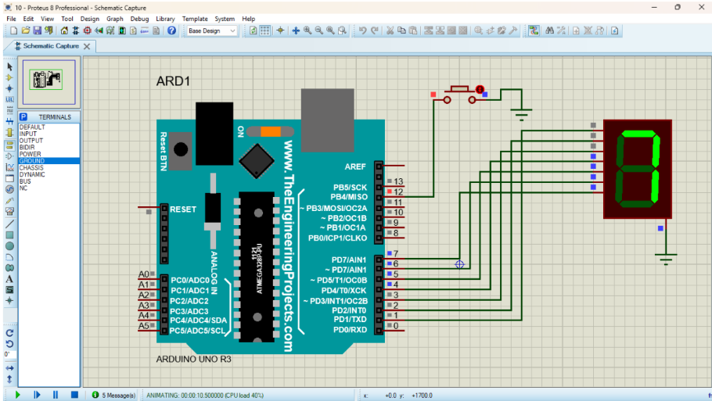

RESULT:
Thus the program has been successfully verified and executed.
6) ARDUINO TO 16x2 LCD DISPLAY USING PROTEUS
AIM:
To write an Embedded C program to interface Arduino Uno and 16 x 2 LCD display using
Arduino Uno and Proteus
PROGRAM:
Arduino to 16x2 LCD Display using Proteus
#include <LiquidCrystal.h>
LiquidCrystal lcd (7, 8, 9, 10, 11, 12);
// your PWM numbers may be different

void setup() {

lcd.begin(16, 2);

lcd.print("put your message here");

}

void loop () {

for (int i=0; 1<13; i++)
}

lcd.scrollDisplayLeft();
delay(700);

}
}
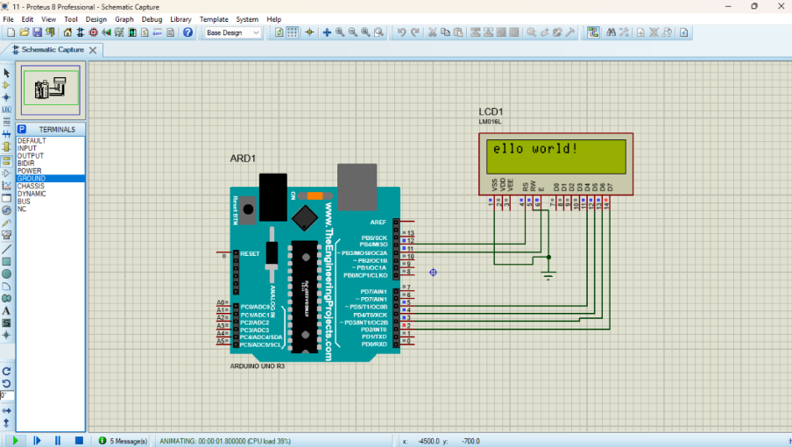
OUTPUT:
RESULT:
Thus the program has been successfully verified and executed.
7) SERIAL COMMUNICATION USING ARDUINO WITH PROTEUS
AIM:
To write an Embedded C program for serial communication using Arduino Uno and
Proteus
PROGRAM:
void setup()
{
Serial.begin(9600); // send and receive at 9600 baud
}

int number = 0;

void loop()
{
Serial.print("Number is ");
Serial.println(number); // print the number
delay(500); // delay half second between numbers
number++; // to the next number
}
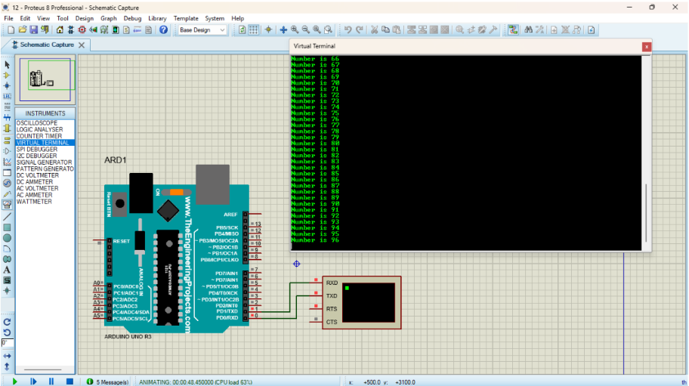
OUTPUT:
RESULT:
Thus the program has been successfully verified and executed.
8) GAS SENSOR MQ-2 IN PROTEUS USING ARDUINO

AIM:
To write an Embedded C program for interfacing Gas Sensor MQ-2 using Arduino Uno and proteus.
PROGRAM:
#define GreenLed 13
#define Sensor A0

void setup(){
pinMode(13,OUTPUT);
pinMode(12,OUTPUT);
pinMode(A0,INPUT);
Serial.begin(9600);

}
void loop() {
int value = analogRead(A0);
Serial.print("Analogic Value coming from the sensor : ");
Serial.println(value);
delay(100);
if(value>600){
digitalWrite(13,HIGH);
}
else{
digitalWrite(13,LOW);
}
delay(20);
}
Code for MQ6 sensor:
int mq6Pin = A0; // MQ-5 analog pin connected to A0

void setup() {
Serial.begin(9600);
}

void loop() {
int sensorValue = analogRead(mq5Pin);
Serial.print("MQ5 Sensor Value: ");
Serial.println(sensorValue);
delay(1000); // 1-second delay
}
OUTPUT:

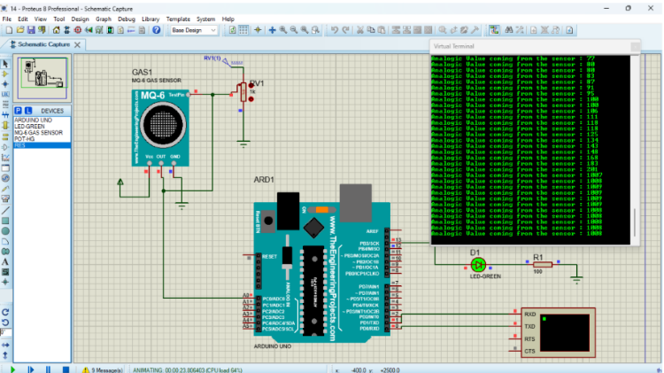
RESULT:
Thus the program has been successfully verified and executed.
9) ULTRASONIC SENSOR IN PROTEUS USING ARDUINO
AIM:
To write an Embedded C program for interfacing Ultrasonic Sensor using Arduino Uno and proteus.
PROGRAM:
// Program Sketch
int trig = 10;
int echo = 9;
long duration;
int cm;
void setup() {
// put your setup code here, to run once:
pinMode(trig, OUTPUT);
pinMode(echo,INPUT);

Serial.begin(9600);
}
void loop() { // Sketch to calculate ultrasonic distance
digitalWrite(trig, LOW);
delayMicroseconds(10);
digitalWrite(trig, HIGH);
delayMicroseconds(10);
digitalWrite(trig, LOW);
delayMicroseconds(10);
duration = pulseIn(echo, HIGH);
cm = (duration/2) * 0.034;
// Print Value on Serial Monitor
Serial.print(" Distance = ");
Serial.print(cm);
Serial.println(" cm");
}
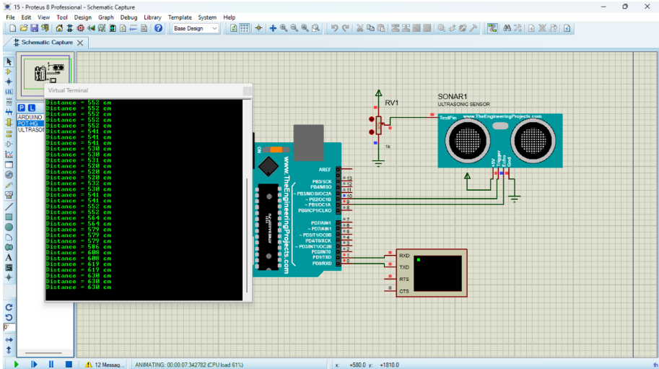
OUTPUT:
RESULT:
Thus the program has been successfully verified and executed.
10)PIR SENSOR IN PROTEUS USING ARDUINO

AIM:
To write an Embedded C program for interfacing PIR Sensor using Arduino Uno and Proteus.
PROGRAM:
int Status = 13; // Digital pin D6
int sensor = 12; // Digital pin D7
void setup() {
Serial.begin(9600);
pinMode(sensor, INPUT); // declare sensor as input
pinMode(Status, OUTPUT); // declare LED as output
}

void loop() {
long state = digitalRead(sensor);
Serial.println(state);
if(state == HIGH) {
digitalWrite (Status, HIGH);
Serial.println("Motion detected!");
delay(1000);
}
else {
digitalWrite (Status, LOW);
Serial.println("Motion absent!");
delay(1000);
}
}
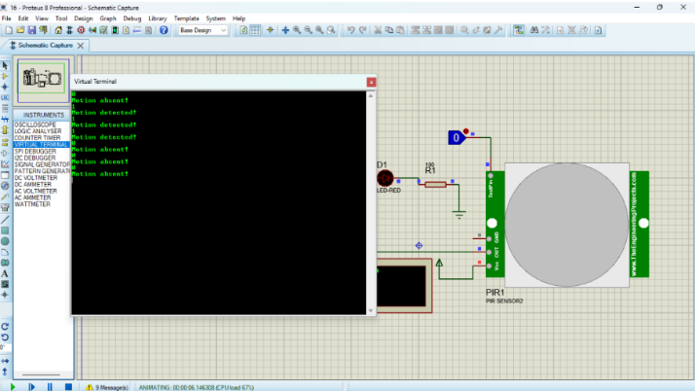
OUTPUT:
RESULT:
Thus the program has been successfully verified and executed.

